**Extension Report – zsau467: 675270401**

**COMPSCI 373 – Barcode Detection Assignment**

**Barcode Reader Extension**

To extend my barcode detection program I used numpy and pyzbar to implement a detection tool to scan for the type and ID of the barcode in the given image. I started by creating a function to cut down the original greyscale array into an array of pixels representing only the section of the image that contains the barcode.

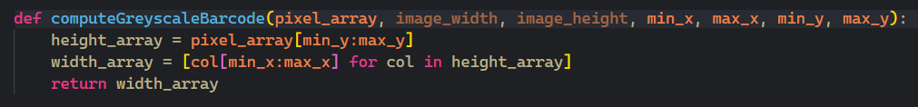After creating the greyscale array representing the barcode segment of the image, I used the numpy extension to create a three-dimensional RGB array with the datatype specified as 8-bit unsigned integers. I then copy the values in the greyscale barcode segment into each colour channel of my three-dimensional array, creating an RGB representation of the barcode segment.

I then used the pyzbar method decode(rgb_image) to take my newly formed three-dimensional array and transform scan it for the relevant barcode data (such as the type and ID). Finally, I displayed the relevant barcode data using the following print code.

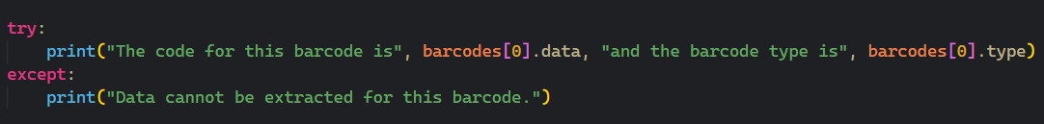Unfortunately I didn’t have enough time to complete my implementation fully and could only successfully retrieve the barcode type and ID from the second barcode ‘Barcode2.png’. I believe that this is because the alignment of the other barcode images isn’t straight, to fix this the barcodes would need to be made horizontal using some sort of further programming. 